**Exercise 1:**

**Setting Up JUnit Scenario: You need to set up JUnit in your Java project to start writing unit tests**.

**1. Create a Package and Java Class:**

package com.rindhiyaa.junit;

public class Calculator {

public int add(int a, int b) {

return a + b;

}

public int subtract(int a, int b) {

return a - b;

}

}

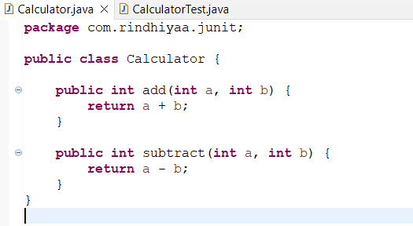

**2. Add JUnit Library:**

**3. Create the Test Class:**

package com.rindhiyaa.junit;

import static org.junit.Assert.*;

import org.junit.Test;

public class CalculatorTest {

Calculator calc = new Calculator();

@Test

public void testAdd() {

assertEquals(5, calc.add(2, 3));

}

@Test

public void testSubtract() {

assertEquals(1, calc.subtract(4, 3));

}

}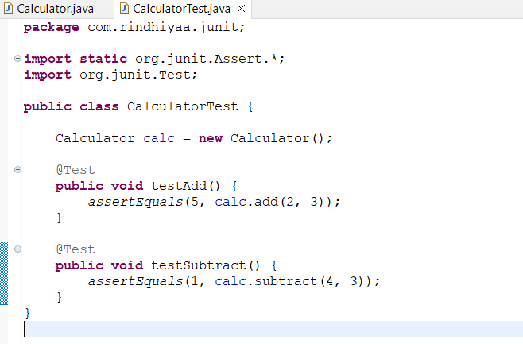

**4. Expected Output**

